Easy connected:
X-Key USB Switch Interface with up to 12 ports

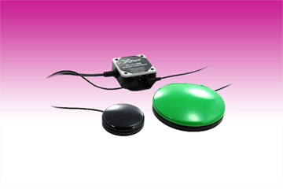
Germering, September 10th, 2015. With the X-Key USB Switch Interface www.tastaturen.com introduces now a comfortable interface for Mac as well as for PC. This product allows the use of 6 up to 12 different switches. The practical interface is connected as a keyboard to the USB port. Then, shortcuts, which are important for the daily work, are programed to the switches, for example: copy, paste, save, open, close. For the connection of hand- or foot-switches to this X-Key interface standard 3.5mm (1/8”) phone plugs are used. So you simplify the daily routine.

A dozen ways to make everyday life easier

The X-Key USB Switch Interface has 6 dual connections. With the optional splitter cables you get up to 12 ports to assign actions such as File Open or Start.
Even short lines of text, such as names, addresses and account numbers can be set. The software for the X-Key switches is available for Windows or Mac OS.
So computer users or system designers can easyly program macros or control functions. All X-Key hand or foot switches can be used.

Price and Availability
The X-Key USB Switch Interface is available for a Net price of about 115 Euro.
More information: http://www.tastaturen.com/x-key-switch

About GeBE
GeBE Computer & Peripherie GmbH was founded in January of 1998. The company develops and manufactures customer specific keyboards, such as foil and short stroke keyboards, as well as protective silicone key linings. GeBE manufactures keyboards but also distributes quality name brand keyboards. Areas of operations are industrial, standard input systems and OEM-Solutions.

GeBE Computer & Peripherie GmbH
Edelweißstraße 20, 82110 Germering
Tel.: 0049 (0)89 894399-0, Fax: 0049(0)89 894399-11
Email: sales@tastaturen.com
URL: http://www.tastaturen.com

Press Contact
Diana Zimmermann
Email: marketing.cp@tastaturen.com

Customer Contact
Paul Pabst
Tel.: 0049 (0)89 894399-0
Fax: 0049 (0)89 894399-11
Email: paul.pabst@tastaturen.com

