Hands up:
Foot pedal controls input commands

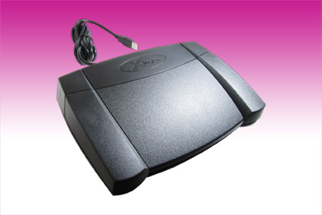
Germering, 23rd May, 2012. www.tastaturen.com presents the X-Key-Pedal, a new generation of foot pedal switch: The X-Key-3 provides two input modes. The customer can choose between a front or rear pressure point. With the front-hinge device shortcuts can be entered by foot pressure on the front pedal section. While the rear-hinge variant is actuated by a pressure point in the rear region of the pedal. Both models have 3 buttons that can be programmed by software. The X-Key-3 is ideal for programming repetitive keystrokes. The foot switch is suitable for data entry that can not be done by hand or for entries that do not require a regular keyboard. It works with any standard keyboard and comes with a USB or PS/2 port.

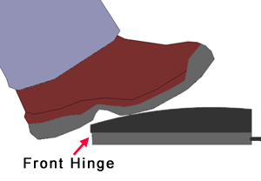
On foot
The new XK-3 Front Hinged Pedal allows the user to rest a foot on the main pedal without activating it and then click with just slight additional pressure. Perfect for mouse click and drag or modifier keys. Only the hinge on main pedal is in the front. The two outside pedals, used for momentary actions, are hinged in the rear.

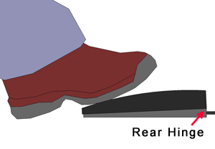
The restyled XK-3 Rear Hinged Pedal features a curved main pedal which allows the user to find the most comfortable angle to rest a foot while keeping the pedal active. Perfect for transcription playback, dictation microphone activation, or video capture. All three pedals on this unit are hinged in the rear.
More information: http://www.tastaturen.com/xkeypedal
About GeBE
GeBE Computer & Peripherie GmbH was founded in January of 1998. The company develops and manufactures customer specific keyboards, such as foil and short stroke keyboards, as well as protective silicone key linings. GeBE manufactures keyboards but also distributes quality name brand keyboards. Areas of operations are industrial, standard input systems and OEM-Solutions.

GeBE Computer & Peripherie GmbH
Untere Bahnhofstraße 38 A, 82110 Germering
Phone: +49 89 894399-0, Fax: +49 89 894399-11
Email: sales@tastaturen.com
URL: http://www.tastaturen.com

Media contact
Astrid Kornelius
Phone: +49 89 894399-0
Email: ak@tastaturen.com

Customer Contact
Paul Pabst
Tel.: +49 89 894399-0
Email: paul.pabst@tastaturen.com

