It keeps on rolling:
TVG-25 Trackball unit with a long lifespan

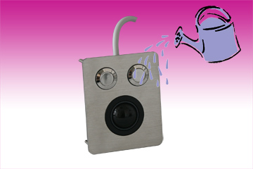
Germering, March 6th, 2013. www.tastaturen.com presents the modular trackball series with an innovative mechanical technology available with a 25 mm diameter. The series is IP65 waterproof and provides the user with extremely sound navigation due to the low actuating power it requires.

The trackball is integrated in a shock absorbing high-grade steel front panel that is offered with two mouse buttons. The trackball is made from a plastic compound reinforced with glass fibers, making it extremely durable through high quality chemical and mechanical materials. The TVG-25 has a lifespan of about 2 million ball revolutions.

Exact Navigation
In combination with the vandal resistant high-grade steel front panel, it can be used in extremely rugged applications. The module is suitable for applications in the industrial manufacturing, medical technology, and food processing industries.

Price and availability
The TVG-25 is available on stock. The price is about 180 Euro. More: http://www.tastaturen.com/tvg-25
About GeBE
GeBE Computer & Peripherie GmbH was founded in January of 1998. The company develops and manufactures customer specific keyboards, such as foil and short stroke keyboards, as well as protective silicone key linings. GeBE manufactures keyboards but also distributes quality name brand keyboards. Areas of operations are industrial, standard input systems and OEM-Solutions.

GeBE Computer & Peripherie GmbH
Untere Bahnhofstraße 38 A, 82110 Germering
Tel.: (089) 894399-0, Fax: (089) 894399-11
Email: sales@tastaturen.com
URL: http://www.tastaturen.com

Press Contact
Astrid Kornelius
Tel.: (089) 894399-0
Fax: (089) 894399-11
Email: ak@tastaturen.com

Customer Contact
Paul Pabst
Tel.: (089) 894399-0
Fax: (089) 894399-11
Email: paul.pabst@tastaturen.com

