Between computers and peripherals:
GCK-978 controller still supports a serial interface

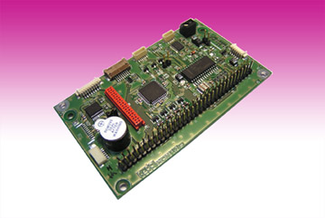
Germering, July 10th, 2013.
The serial interface is used to exchange data between computers and peripheral devices. Although it belongs to the 'old' interfaces, it remains important for replacement or extending older machine controls. www.tastaturen.com provides the GCK-978, a tool for programming a matrix keyboard controller, to control the RS232 serial interface. In a few seconds the user can define individual keys or alternatively assign any key or key combination also macros without programming knowledge. Similarly, system settings like interface (USB-PS / 2 autodetect, USB, PS / 2 or RS232) or key click can be set.

The controller board of the GCK-978 series are suitable for the most common techniques such as slides, contacts and rubber keyboards. Connectable peripherals such as touchpad, trackball, joystick, memory card reader or screen, can be set up using the GCK-978.

Price and availability
The „GCK-978“ is available on stock. The price is about 80 Euro. More: http://www.tastaturen.com/gck-978

About GeBE
GeBE Computer & Peripherie GmbH was founded in January of 1998. The company develops and manufactures customer specific keyboards, such as foil and short stroke keyboards, as well as protective silicone key linings. GeBE manufactures keyboards but also distributes quality name brand keyboards. Areas of operations are industrial, standard input systems and OEM-Solutions.

GeBE Computer & Peripherie GmbH
Edelweißstraße 20, 82110 Germering
Tel.: (089) 894399-0, Fax: (089) 894399-11
Email: sales@tastaturen.com
URL: http://www.tastaturen.com

Press Contact
Astrid Kornelius
Tel.: (089) 894399-14
Fax: (089) 894399-11
Email: ak@tastaturen.com

Customer Contact
Paul Pabst
Tel.: (089) 894399-0
Fax: (089) 894399-11
Email: paul.pabst@tastaturen.com

